**Advance Excel Assignment 1**

1. What do you mean by cells in an excel sheet?
   1. Cell is an intersection of a Row and Column in an Excel Sheet
2. How can you restrict someone from copying a cell from your worksheet?
   1. Yes, you can restrict by protecting cells in excel sheet.

for that you will have to go to Review Tab>Protect Sheet

After it you will see a dialog box like this

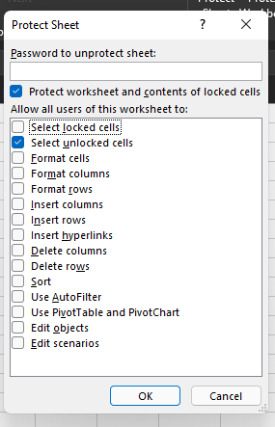

You need to uncheck ‘Select Locked Cells’ options and click ‘Ok’  
Now locked cells will not be selected so those cells will not be copied.

**Note:** You can make some cells unprotected before locking sheet by going to sheet right click menu>format cells> Protection> (uncheck Locked and Press ‘Ok’)

1. How to move or copy the worksheet into another workbook?
   1. Right click on the worksheet tab and select Move or Copy.
   2. Select the Create a copy checkbox.
   3. Under Before sheet, select where you want to place the copy.
   4. Select OK.
2. Which key is used as a shortcut for opening a new window document?
   1. Ctrl+N
3. What are the things that we can notice after opening the Excel interface?
   1. Blank spreadsheet (Also known as Worksheet) with Options at the top available showing Various Editing options and much more.
4. When to use a relative cell reference in excel?
   1. A simple Example we can use is –
      1. We can use Relative Cell Reference we want to find the SUM of Column A per Row + Column B per Row; Then we can use Relative Cell Reference in Column C using the SUM formula.

*(It would also be helpful in dragging the formula down)*